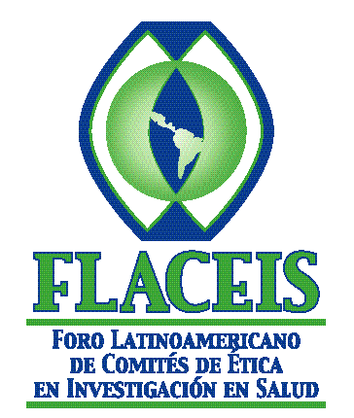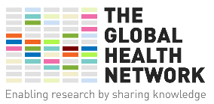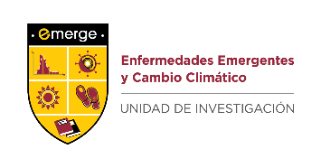
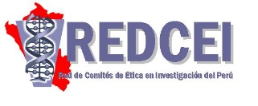

International Workshop on Research Ethics: New Challenges Executive Summary

The International Workshop on Research Ethics: New Challenges was held in Lima, Peru from 28 to 29 August 2018.

This event was jointly organized by the Latin American Forum for Research Ethics Committees (FLACEIS per initials in Spanish), the Peruvian IRB Network (REDCEI), and Universidad Peruana Cayetano Heredia, with the sponsorship of The Global Health Network, EDUPYME and EMERGE, without their support, this event could not have been held.
This collaborative educational activity among Peruvian and international organizations aimed at updating Peruvian IRB members and investigators on new study designs for clinical trials and their ethical aspects, as well as sharing with our international attendees the Peru progress in the regulatory system, how to work in IRB networks and the role of IRBs in scientific integrity issues.

The Global Forum for Bioethics in Research (GFBR, per initials in English) gathered in November 2017 in Thailand under a central theme: Alternative Study Design in Clinical Trials, among them Cluster randomized trials, Stepped wedge trials, Adaptative platform trials and Controlled human infection models or CHIMs. These designs are already in use in research protocols in other regions of the world and it is very important for our scientific community, -and the IRBs are part of it- to learn about them so they can evaluate the protocols adequately.

There were two keynote speakers, Dr. Heinner Guio from the Peruvian National Institute of Health (INS and Dr. Ricardo Palacios, researchers from the Butantan Institute, Sao Paulo, Brazil.

Dr. Hans Vasquez, director of the Peruvian National Institute of Health (INS) inaugurated the workshop and emphasized the importance of strengthening clinical research in Peru, through its various partners and recognized the commitment of the organizers of this event with research ethics in Peru in the past few years. He ended his remarks by wishing success in the goal of reinforcing skills of both, IRBs and investigators, as well. Following Dr. Vasquez’ remarks, Dr. Heinner Guio, researcher at the Peruvian INS, shared his experience and data of his project entitled “The Peruvian Human Genome Project,” a Peruvian-led study providing information on the various genomic and genetic information of the various Peruvian populations. This study was conducted in close coordination with the local IRB and with community consultations. Dr. Nora Espiritu, director of the regulatory agency for clinical trials in Peru (Oficina General de Investigación y Transferencia Tecnológica -OGITT), a division of the INS, shared with the audience the progress made in Peru with the new regulation and the challenges ahead.

The event took place in the course of two days. The first day was dedicated to the theme Alternative Study Design in Clinical Trials. Dr. Palacios’ presentations received high regards from the audience because of his knowledge, clarity, methodology and experience.

In addition to the presentation and corresponding hands-on workshops, there was an additional study protocol discussed during the event. This protocol had been submitted to the IRB in CIDEIM Cali, Colombia. On the second day, there was a lively discussion on the new regulation of clinical trials, biobanks, vulnerability in Research, IRB autonomy, working in networks. The course ended with two presentations regarding IRB functions, such as challenges found in the initial review of a study and how to manage IRB workload.

In the words of one of our foreign speakers, Dr. Alger. “…this event provided a unique opportunity to appreciate and understand the various components in a well-consolidated health research system, such as the Peruvian system, as compared to others.” Dr. Alger has collaborated with the Peruvian IRB Network since 2014 and during this event, she was able to interact with several members and exchange experiences, as well as learning what is happening in Argentina, Brazil, Colombia and the Dominican Republic. “… The central theme, alternative designs in clinical trials, is extremely important and will fill existing information gaps in our local IRBs.” Finally, Dr. Alger considers “… my participation allowed the audience to know what is happening with the Honduran IRBs and IRB Network, and how we have put to good use the training opportunities provided by The Global Health Network platform.”

Remarks from another foreign attendee emphasized “… The selection of topics, knowledge and experience of the speakers and the depth with which these topics were addressed in an intensive workshop, as well as the coherence…, the course has been one more demonstration of the importance and complexity of the work done by IRBs.”

A total of 130 people attended the course, among speakers, attendees and logistic support, 92/130 were women and 7/130 were foreign attendees/speakers coming from IRBs and institutions in Argentina, Brazil, Colombia, Honduras and the Dominican Republic. A total of 25 Peruvian institutions were represented at this event, mostly IRBs but there were also investigators from Contract Research Organizations (CROs) and universities. The presentations led to useful and interesting discussions that helped reinforce current or controversial topics.

One of the recommendations provided was to try to hold a similar event either yearly or every two years.

