WORKSHOP ATTENDANCE REGISTRATION FORM

Fill in this registration form by ticking the boxes as appropriate

Course details
Course name: |  |  |  |  |  | Date: |  |  |  | Location:
This course will be delivered in English. Are you OK with this? |  |  |  |  |  | Yes |  |  | No |  |  | Other
How did you learn about this course? |  |  |  | Poster/leaflet | Email | Relief Web |  |  | My Supervisor |  |  | other
Applicant details (Please write your name in CAPITAL LETTERS)
Prof/Dr./Mr/Mrs/Ms |  | Full Name:
Please indicate if you if you are employed (self sponsored participants may  omit this part) |  |  |  |  |  |  |  |  | Male Female
Your Organisation’s Name: |  |  |  |  |  |  |  |  | Type of work:
Type of organisation |  | INGO | NGO UN |  | CBO | Government Agencies
Organisation address: |  |  |  |  |  | Phone: |  |  |  |  | Fax:
Your Job title: |  |  |  |  |  |  | Your duty Station:
Your personal contact |  | Phone (s): |  |  |  |  |  | Email:
Other information
What are the 3 key responsibilities in your current job? (self sponsored participants may omit this part)
1.
2.
3.
Please state at least 3 main expectations for attending this course
1.

2.

3.

Do you have any “special” needs? Yes  No |  | Hearing | Diet |  | Any other?
If yes, please specify :
Payment details
Course fees (in USD): | Payment by:  Cash Cheque bank transfer |  |  | Name:
 |  |  |  | Job title:
 |  |  |  | Phone:
 |  |  |  | Email:

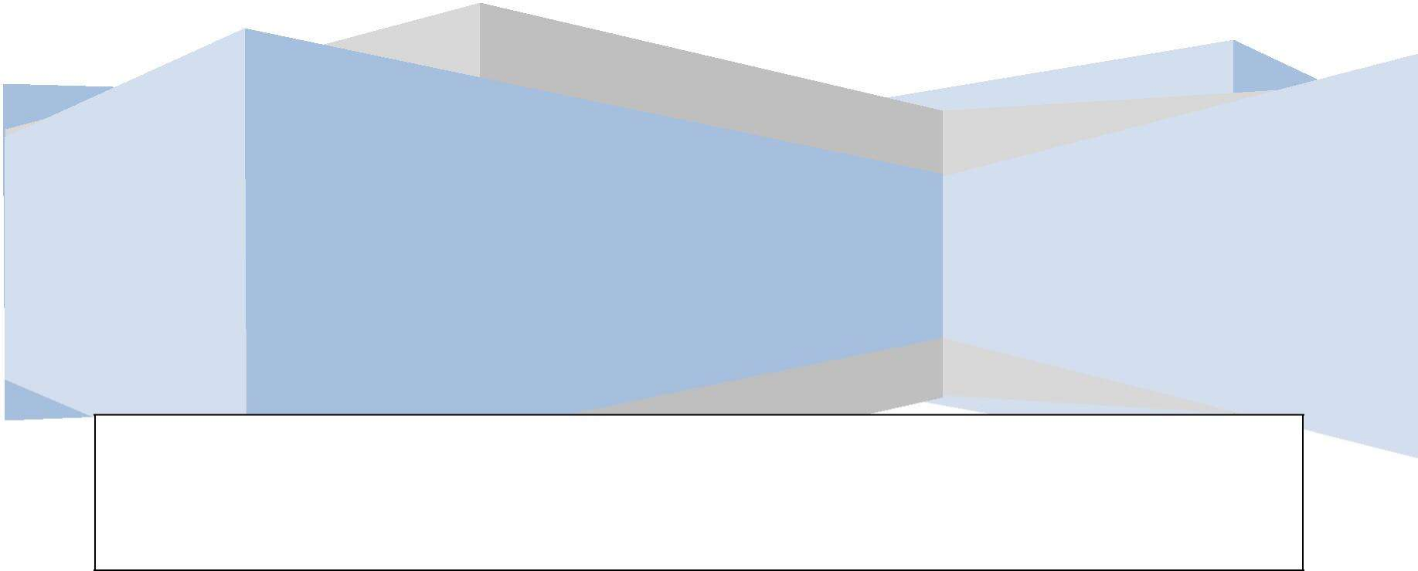I Prof/Dr/Ms/Mr./Mrs.-------------------------------------------the ………………………………….(title) agree to pay Asset Africa Institute a total amount of KSHS/USD ………………………….. as payment for cost of workshop participation and certificate only

(Signature/or print your name in full)

Please send the scanned copy of the completed application form to info@assetafrica.co.ke for your name to be enrolled on the workshop participation register

For more information or enquiries kindly contact:

ASSET AFRIKA INSTITUTE, Trust Mansion Hse, Tubman Road off Koinange Street P.O. Box 12903 – 00100, Nairobi, Kenya, Phone: +254 -722 469454/720986965
www.assetsafrika.org, Email: info@assetafrica.co.ke/assetafrika@gmail.com

